HOLY BAPTISM

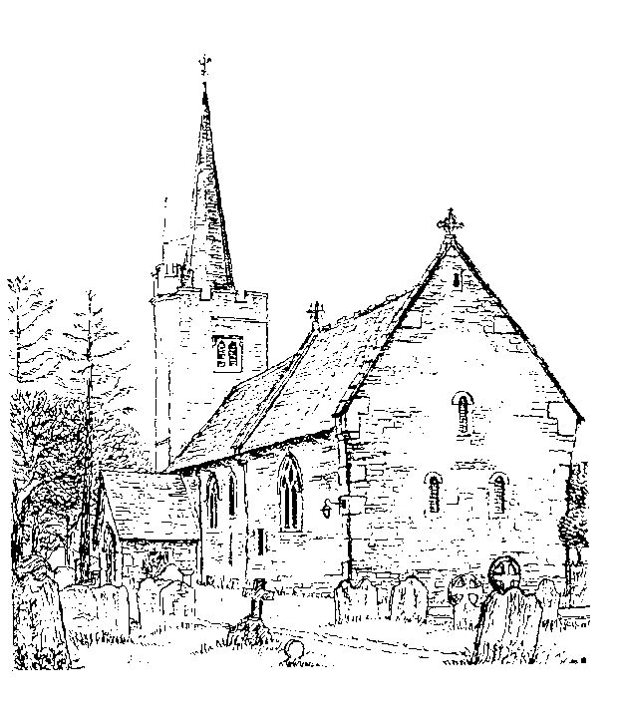

St Margaret’s

Barming

Holy Baptism

Baptism marks the beginning of a journey with God which continues for the rest of our lives, the first step in response to God’s love.

For all involved, particularly the parents, godparents and sponsors, it is a joyful moment when we rejoice in what God has done for us in Christ, making serious promises and declaring the faith. The wider community of the local church and friends welcome the new Christian, promising support and prayer for the future. Hearing and doing these things provides an opportunity to remember our own baptism and reflect on the progress made on that journey, which is now to be shared with new members of the family of the Church.

The service paints many vivid pictures of what happens on the Christian way. There is the sign of the cross, the badge of faith in the Christian journey, which reminds us of Christ’s death for us. Our ‘drowning’ in the water of baptism, (where we believe we die to sin and are raised to new life), unites us to Christ’s dying and rising, Water is also a sign of new life, as we are born again by water and the Spirit. This reminds us of Jesus’ baptism. And as a sign of that new life, there is a lighted candle, a picture of the light of Christ conquering the darkness of evil. Everyone who is baptized walks in that light for the rest of their lives.

As we pray for this child who is to be baptised today picture him with yourself and the whole Church throughout the ages, journeying into God’s love.

**Introduction & Welcome**

**Hymn**

*To the parents and godparents*

Do you wish that this child is baptised

*Parents, then godparents*

**We do**

Faith is the gift of God to his people.  
In baptism the Lord is adding to our number those whom he is calling.

People of God, will you welcome *name* and uphold him in his new life in Christ?

**With the help of God, we will.**

The Church receives *name* with joy. Today we are trusting God for his growth in faith. Will you pray for him, draw him by your example into the community of faith and walk with him in the way of Christ?  
**With the help of God, we will.**

In baptism this child begins his journey in faith.  
You speak for him today.  
Will you care for him, and helphim to takehis place within the life and worship of Christ’s Church?  
**With the help of God, we will.**

In baptism, God calls us out of darkness into his marvellous light. To follow Christ means dying to sin and rising to new life with him. Therefore I ask:

Do you reject the devil and all rebellion against God

**I reject them**

Do you renounce evil?  
**I renounce evil.**

Do you repent of the sins that separate us from God and neighbour ?  
**I repent of them**

Do you turn to Christ ?  
**I turn to Christ.**

Do you come to Christ, the way, the truth and the life?  
**I come to Christ**

**Signing with a cross**

*( The leader , parents , godparents and supporters may sign the child with a cross)*

Christ claims you for his own. Receive the sign of his cross. Do not be ashamed to confess the faith of Christ crucified.

**Fight valiantly as a disciple of Christ against sin, the world and the devil, and remain faithful to Christ to the end of your life**

May almighty God deliver you from the powers of darkness,  
restore in you the image of his glory, and lead you in the light and obedience of Christ. **Amen.**

**Reading**

*We move to the font—please bring this order of service with you*

Praise God who made heaven and earth,  
**who keeps his promise for ever.**

Let us give thanks to the Lord our God.  
**It is right to give thanks and praise.**

We thank you, almighty God, for the gift of water  
to sustain, refresh and cleanse all life.  
Now sanctify this water that, by the power of your Holy Spirit,  
*name* may be cleansed from sin and born again.  
Renewed in your image, may he walk by the light of faith  
and continue for ever in the risen life of Jesus Christ our Lord;  
to whom with you and the Holy Spirit be all honour and glory, now and for ever. **Amen.**

**The Baptism**

Let us affirm, our faith in Jesus Christ for ourselves and for this child

Do you believe and trust in God the Father, source of all being and life, the one for whom we exist?

**I believe and trust in him**

Do you believe and trust in God the Son, who took our human nature, died for us and rose again?

**I believe and trust in him**

Do you believe and trust in God the Holy Spirit, who gives life to the people of God and makes Christ known in the world?

**I believe and trust in him**

***Name*** I baptise you in the name of God the Father, God the Son and God the Holy Spirit

**Amen**

*A godparent holds the child*

May God, who has received you by baptism into his Church,  
pour upon you the riches of his grace, that within the company of Christ’s pilgrim people you may daily be renewed by his anointing Spirit, and come to the inheritance of the saints in glory.

**Amen.**

*We return to our places*

**Reading**

You have brought *name* to baptism knowing that Jesus died and rose again for him and trusting in the promise that God hears and answers prayer. We have prayed that in Jesus Christ he will know the forgiveness of his sins and the new life of the Spirit.

As he grows up, he will need the help and encouragement of the Christian community, so that he may learn to know God in public worship and private prayer, follow Jesus Christ in the life of faith, serve his neighbour after the example of Christ, and in due course come to confirmation.

As part of the Church of Christ, we all have a duty to support this child and the whole family by prayer, example and teaching. Parents and godparents have a special responsibility for guiding and helping him in his early years. This is a demanding task for which you will need the help and grace of God.

Therefore let us now pray together for grace in guiding *name* in the way of faith.

**Faithful and loving God, bless all those who care for *name* and grant him your gifts of love, wisdom and faith. Pour upon him your healing and reconciling love, and protect his home from all evil. Fill him with the light of your presence and establish him in the joy of your kingdom, through Jesus Christ our Lord.Amen.**

**The Welcome**

There is one Lord, one faith, one baptism:  
by one Spirit we are all baptized into one body.

**We welcome you into the fellowship of faith; we are children of the same heavenly Father. Welcome.**

**The Blessing**

The God of all Grace   
who called you to his eternal glory in Christ Jesus,  
establish, strengthen and settle you in the faith;  
and the blessing of God almighty,  
the Father, the Son, and the Holy Spirit,  
be among you and remain with you always.  
**Amen.**

**Hymn**

**Giving of a Lighted Candle**

God has delivered us from the dominion of darkness and has given us a place with the saints in light. Today *name*, you have received the light of Christ; walk in this light all the days of your life.

**Shine as a light in the world to the glory of God the Father.**

Go in the light and peace of Christ.  
**Thanks be to God.**

*Some material included in this service is copyright: © The Archbishops' Council 2000*